Comms Framework Transport Design

TOC
1. introduction 2
1.1 Purpose and Scope 2
2. Overview 3
3. Design 5
3.1 Channel Establishment 5
3.2 A Message 6
3.3 Channel dynamics 7
3.3.1 CTransportChipper 7
3.3.2 CTransportSelfSender 7
3.4 API 8
3.4.1 MTransportSender 8
3.4.2 CCommsTransport 8
3.5 Legacy Messages and addressing 8
4. Future Evolution 9
4.1 Synchronous Message Posting 9
4.2 Cross Process Communication 9
5. Further Information 10
5.1 People 10
5.2 References 10
5.3 Open Issues 10
5.4 Glossary 10
5.5 Document History 10

introduction

Purpose and Scope
This document details the inter-thread transport mechanism provided by the Comms Framework, including notes on the proper uses for it, how to design protocols to work well with it, and the API provided.

Overview
The following diagram presents the basic principles the CF Transport component is built upon; i.e.:
- There is a bidirectional (RMsgQueueBase based) queue/channel between every two threads of execution that need to communicate;
- Each queue is made available via by a (tx) chipper object that can fragment large buffers into small chips (smaller buffers) each fitting into the queue’s slot. The large, message bearing buffers are not arbitrarily large, because the transport recreates the messages on the destination’s stack. In fact most of the large buffers, as the transport bets, will typically fit into individual chips, so the act of chipping will not typically happen. Without the chipping though, all messages will have to fit into the queue slot, making the slots too large than they typically need to be. The size difference between the large buffers and chips is simply a tradeoff between the overflow risk and the memory footprint.
- Any given thread of execution will have a number of chippers each leading to one of the other threads the given thread needs to communicate with. Such collection of chippers becomes a thread-local, singleton transport sender object that the entities dwelling in the given thread can (directly or otherwise) use to communicate with entities dwelling in different threads.
- A transport sender takes the responsibility of infallibly (no error conditions) delivering messages to the destination threads.
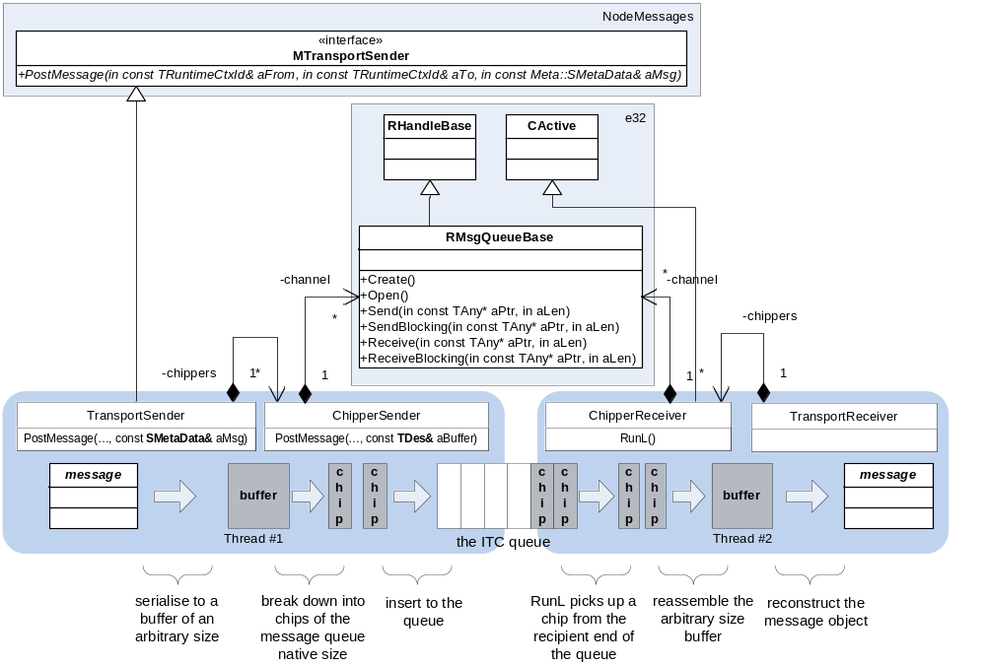
Figure 1 - The basic principle

The consequences of this approach are important, as they shape the resulting communication and deployment model, in particular:
- Message passing is one of many ways to go about multithreaded programming and it is arguably the most clear-cut way of dividing function into multiple execution contexts. Message passing as a multithreaded programming technique doesn’t require re-entrant code and hence it is a strong hint that there is no re-entrant code in the problem domain. It is therefore meaningful to state that entities (objects) in the problem domain dwell in specific threads of execution.
- A thread of execution is an OS abstraction of a task. A method is a C++ abstraction of a task. A class/object is a C++ primitive for expressing structure. The message passing principle enforces thread-bound objects and therefore polarizes the structure against the function, i.e.: it forces the structure (the model) to express the functional division.
- The infallibility principle puts message passing conceptually close to invoking a C++ method (or a C function), i.e.: a method execution can fail, but the method can always be reliably executed. In other words, one does not attempt to call a method and equally the transport does not attempt to deliver a message (it simply delivers it).
- The MTransportSender interface enforces strictly asynchronous message exchange, which makes the “message is like a C++ method” analogy slightly more relaxed. The are three reasons for that:
  - Asynchronous regime was required by the architecture (see [2]);
  - It was easier to do;
  - It was safer to do (doesn’t introduce deadlock worries);
Inter-thread communication is based upon messages. The expectation is that these will be used for fully asynchronous design (other than for supporting legacy needs such as the NIF interfaces). Therefore although it is convenient to use terminology such as methods and parameters, and technology such as member function pointers for dispatching the message in the recipient, we should probably be careful to avoid describing them as function calls, lest users of the transport write code such as [utter fantasy case of control-thread code talking to data and management threads:
flow.Detach(interface); // on return the interface is fully idle
layerManager.InterfaceDown(flow);
In reality it’s wholly possible that the data thread hasn’t received, let alone completed, the flow detach message when the management thread performs the interface down function. It may well be that the convention of naming all such functions SendXXX() is followed to keep this issue visible, especially for future maintenance coders.

Design
The following diagram depicts the high level design of the CF Transport component.
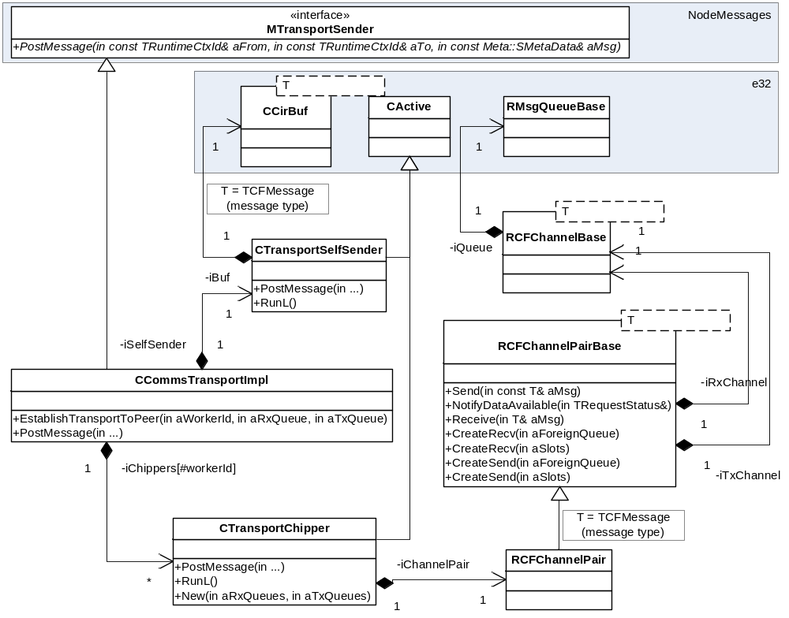
Figure 2 - High Level Design

Note that both the transport instance as well as individual chippers are full duplex.

Channel Establishment
Channels (message queues among the threads of execution) can be established in a number of ways depending on the level of abstraction:
- RCFChannelPair is a generic representation of a duplex message queue endpoint – one of two enpoints that share two (A->B and A<-B) RMsgQueueBase message queues. An RCFChannelPair can attach to pre-created queues (aForeignQueue overloads) or construct new ones (aSlots overload). Clearly both ends cannot create the queues (at least one must attach) and following that there are two conceivable approaches:
  - For each unidirectional queue, the queue is created on one end and communicated to the other (by means external to the CF Transport component);
  - All unidirectional queues are construted externally and passed (by means external to the CF Transport component) to RCFChannelPair, which means RCFChannelPair never constructs the queues.
- Looking at the CTransportChipper and CCommsTransportImpl it is clear that they never allow (a) and that they always require unidirectional queues to be supplied from elsewhere (see [1]).
The high level design diagram (see [Figure 2]) provides hints that the CF Transport will also be able to post messages to the local thread (self) and thus entirely abstract away the recipient’s location (transport caller can be oblivious to the recipient’s thread affinity). Of course the local loopback transport channel (CTransportSelfSender) doesn’t need to be explicitly established.

A Message
MTransportSender prescribes a message to be of Meta::SMetaData type (see [2]), which makes it type-identifiable and serialisable. This is somewhat relaxed in relation to what CCommsTransportImpl (as an implementer of MTransportSender) considers a message, i.e.: CCommsTransportImpl requires that, with the exception of legacy ESock messages (see [3.5]), messages are of Messages::TSignalBase (see [R3]) type. Messages::TSignalBase additionally makes them:
- Constructable with their virtual constructors. Messages dispatchable on a given transport endpoint (thread) must register their virual constructors with the transport (CCommsTransportImpl:: NewL(MWorkerThreadRegister& aThreadRegister, const CMetaDataVirtualCtorInPlace* aVirtCtor)) otherwise the transport will panic with ECFInterfaceNotRegistered.
- Part of the delivery chain. The CF Transport takes the responsibility to deliver a message from one thread to another and it will delegate the rest of the delivery path to the very message by calling Messages::TSignalBase::DispatchL(…);
With such definition of the message, the transport needs to make sure that:
- Its sending end serializes the message onto a flat buffer using Meta::SMetaData::StoreL - this will store the content and the Meta::STypeId of the message.
- Its receiving end reconstructs and deserialises the message from the flat buffer using the virtual construction registry. Reconstruction must use placement new construction (over a transport provided and stack based inplaceBuf). The virtual construction registry is used as follows:
TSignalBase* msg = static_cast<TSignalBase*>(iVirtCtor->New(aMsg, inplaceBuf));

Channel dynamics
Transport queues (channels) have limited length and it is important to understand what happens if they run out of space. It is even more important to understand why they might run out of space. Both the queue congestion conditions and the corrective action differ depending on whether the message in question is going via a cross thread (CTransportChipper) or self sender (CTransportSelfSender) chippers.

CTransportChipper
CTransportChipper (on CTransportChipper::PostMessage) will attempt to append one or more message chips to a queue (RMsgQueueBase) expecting the thread on the opposite end of the queue to drain it at some point. In some circumstances the destination thread will not drain its queue in time and the sender may face the situation when the queue is full. CTransportChipper still has the obligation of infallibly delivering messages to the destination threads and it makes the best effort, pragmatic attempt ensuring delivery in a stable system state. If the destination does not drain the queue in a reasonable time (configurable, determined empirically) then the system is deemed unstable and the chipper panics. In particular the destination thread may have crashed (=system unstable). The destination thread could have also executed User::After(a_very_long_time) (=system unstable because the destination thread behaves irresponsibly).
Given the stability boundaries, the best effort attempt is achieved by CTransportChipper::PostMessage simply blocking for queue space rather than returning an error. Superficially this approach opposes the goal of avoiding synchronisity; however underlying it is the expectation that queues will be sized (configured) appropriately to avoid blocking in normal circumstances. Queue congestion typically indicates that the receiving thread isn’t being scheduled enough and so blocking the sending thread will often help.
Of course resorting to blocking calls, in very unlucky conditions, may lead to the recipient thread not draining its queue since blocked in an attempt to send in the reverse direction and it is blocked because the sender doesn’t drain its queue, which would lead to a deadlock. The deadlock is prevented by the sender draining its own inbound queue when its outbound queue overflows and sleeping briefly to let the other end act. The inbound queue is drained to a ‘queue from the queue’ on the recipient side. The queue from the queue grows dynamically (memory permitting) and if it doesn’t the sender goes to sleep. After a number of loops (configurable at build-time; currently 30 iterations of 0.5s sleeps) the sender gives up and requests that the receiver thread is panicked for becoming unresponsive.

CTransportSelfSender
Of course the self sender will not have to make assumptions about the stability of the destination thread since it is both the source and the destination. There are typically two reasons why the self sender’s queue can fill up:
- The thread (or more likely the entities dwelling on it) bombarde the queue by issuing too many messages within a single callstack (e.g.: single invocation of CTransportSelfSender::RunL). What too many is is of course very relative.
- The thread is is bombarded from the outside. If the external queues are drained at a higher priority than the CTransportSelfSender queue (active objects are prioritied differently) then the external thread may spawn too many tasks on the destination thread, tasks that will collectively fill up the queue.
The former is considered irresponsible behaviour (similar to triggering stack overflow), which impedes system stability. The latter is minimized by ensuring that the CTransportSelfSender active object runs at a higher priority than the peer CTransportChippers.

API
The CF Transport offers platform API and it is depicted on the diagram below
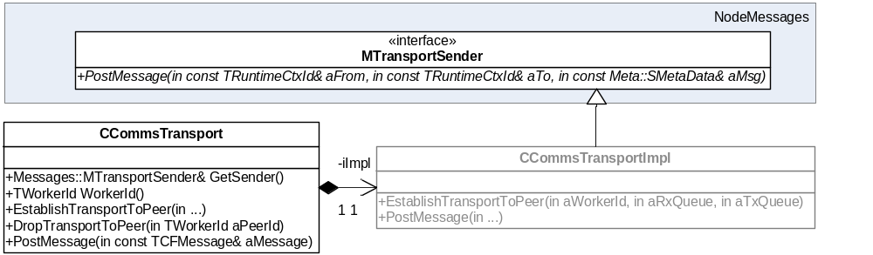
Figure 3 - CF Transport API

MTransportSender
As mentioned earlier, implementations of
MTransportSender::PostMessage(
const TRuntimeCtxId& aPostFrom,
const TRuntimeCtxId& aPostTo,
const Meta::SMetaData& aMessage)
(including CCommsTransportImpl) must infallibly and asynchronously (in a different callstack) deliver aMessage to aPostTo.
The addressing demanded by MTransportSender entirely is defined by the NodeMessages component (see [3]).

CCommsTransport
CCommsTransport is a pure backwards-compatibility-proof handle to the CCommsTransportImpl body. How instances of CCommsTransport are offered to the callers is technically out of scope for this document, but it is worth mentioning that current callers obtain it from the Thread Local Storage.

Legacy Messages and addressing
The CF Transport component has a relatively rich history and that history is visible in its implementation. Notably, the component has been initially implemented to dispatch a closed set of TCFMessages among the worker threads of ESockSvr (see [4]). The CF Transport still has the obligation to do so paying a tangible code complexity tax. This complexity probably deserves removing. This can be achieved by getting rid of the TCFMessages and switch all communication to use Messages::TSignalBase tokens. This section describes the legacy responsiblities of the CF Transport component.
TODO.

Future Evolution

Synchronous Message Posting
Attempts to have the CF Transport offer synchronous message exchange routines have been for now abandoned. Some commented out code exists to facilitate for that, but this code should be considered unreliable. The attempts have been abandoned because, when put under scrutiny, they proofed obsolete – the multithreaded architecture couldn’t cope with supporting synchronous calls, mostly due to:
- Deadlock risk;
- API design regimes, where we preferred to limit the options and only allow for asynchronous APIs (see [2]);

Cross Process Communication
There technically isn’t anything stopping the CF Transport to start working cross process. This simply hasn’t been done yet, because it requires non-trivial (yet feasible) changes to Rootserver (see [1]) to allow threads living in separate processes to get introduced to each other.

Further Information

People
Role | Person / People
Reviewers | Thomas Goodfellow
Contributors | Remek Zajac, Thomas Goodfellow
Distribution

References
No. | Document Reference | Version | Description
[R1] | …\commsfw\commsfwsupport\commselements\rootserver\documentation\Root Server Design Document.doc | 3.1 | Rootserver design document
[R2] | …\commsfw\commsfwsupport\commselements\NetMeta\Documentation\NetMeta_Design_Document.doc | 1.2 | NetMeta design document
[R3] | …\commsfw\commsfwsupport\commselements\nodemessages\documentation\SGL.GT0359.057.NodeMessages_Design.doc | 1.0 | NodeMessages design document
[R4] | …\commsfw\datacommsserver\esockserver\Documentation\ESock_Design.doc | 2.0 | ESock Design

Open Issues

Glossary
Term | Definition

Document History
Date | Version | Status | Author | Description
15-10-2009 | 0.1 | Draft | Remek Zajac | First draft

